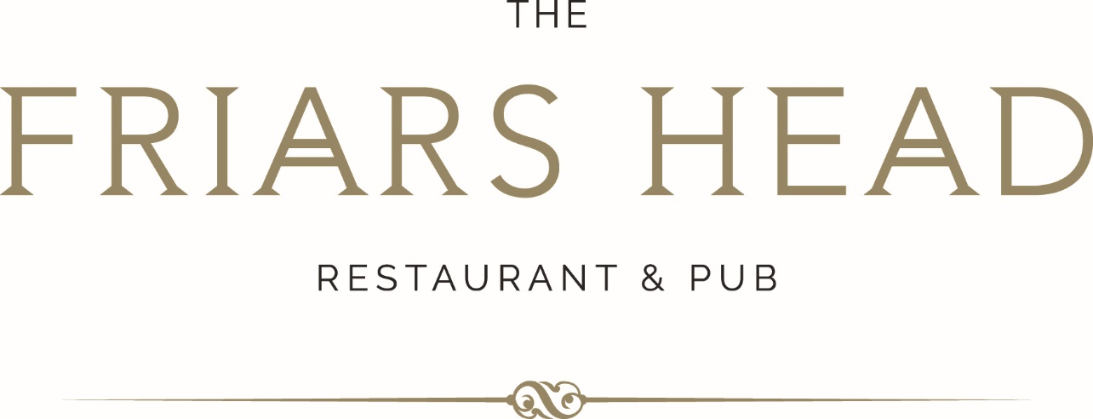

SUNDAY LUNCH

SOUP OF THE DAY (v/gf avail)
crusty bread
8

PRAWN COCKTAIL (gf avail)
marie rose sauce, baby gem lettuce, brown bread & butter
9

CREAMY GARLIC MUSHROOMS (gf avail)
melted cheese, crusty bread
9

FRIED GOATS CHEESE & BLACK PUDDING (v avail)
mixed leaf, balsamic
9.5

__________________________________________

ROAST BEEF 22 (gf avail)
roast potatoes, mash potato, yorkshire pudding, tender stem broccoli, roasted carrot & parsnip

ROAST PORK 19.5 (gf avail)
roast potatoes, crackling, sage & onion stuffing, yorkshire pudding, mash potato
tender stem broccoli, roasted carrot & parsnip

ROAST CHICKEN 19.5 (gf avail)
roast potatoes, sage & onion stuffing, mash potato, yorkshire pudding, roasted carrot & parsnip,
tender stem broccoli

TRIO OF MEATS – BEEF CHICKEN & PORK 24 (gf avail)
roast potatoes, sage & onion stuffing, crackling, mash potato, yorkshire pudding
tender stem broccoli, roasted carrot & parsnip

MEAT FREE SUNDAY LUNCH 19 (gf avail)
bubble & squeak patty, roast potatoes, yorkshire pudding, vegetarian gravy
tender stem broccoli, roasted carrot & parsnip

FISH & CHIPS 21 (gf avail)
beer batter, hand cut chips, tartare sauce, mushy peas, lemon

DESSERT MENU

STICKY TOFFEE PUDDING (v)
8.5
sticky date sponge, butterscotch sauce
vanilla ice cream

FRUIT CRUMBLE OF THE DAY (v)
8.5
topped with an oat crumb, served with cream, custard or vanilla ice cream

GOLDEN SYRUP SPONGE (v)
8.5
served with vanilla custard

CHOCOLATE BROWNIE (v/gf avail)
9
warm chocolate brownie, chocolate sauce, salted caramel ice cream (gf avail)

CHEESECAKE OF THE DAY (v)
served with pouring cream
9

BAILEYS BREAD & BUTTER PUDDING (v)
9.5
baileys, brioche, chocolate, raisins
pouring cream

FRIARS GLORY (v/gf/ve avail)
10
one scoop of vanilla, chocolate, salted caramel ice cream
brownie chunks, toffee sauce, topped with sprinkles

CHEESEBOARD
14.5
cheddar, smoked applewood, blue stilton, wensleydale & cranberries
crackers & accompaniments

(v) vegetarian, (ve) vegan, (gf) gluten free
all food is prepared in kitchens where nuts, gluten & other allergens could be present and our menu descriptions cannot include all ingredients. full allergen information is available, please ask a member of staff for allergen information.

